OUTPUT SCREENSHOTS – DAY 17 – 03.05.2024

1. To Print the storeid and number of orders for the store

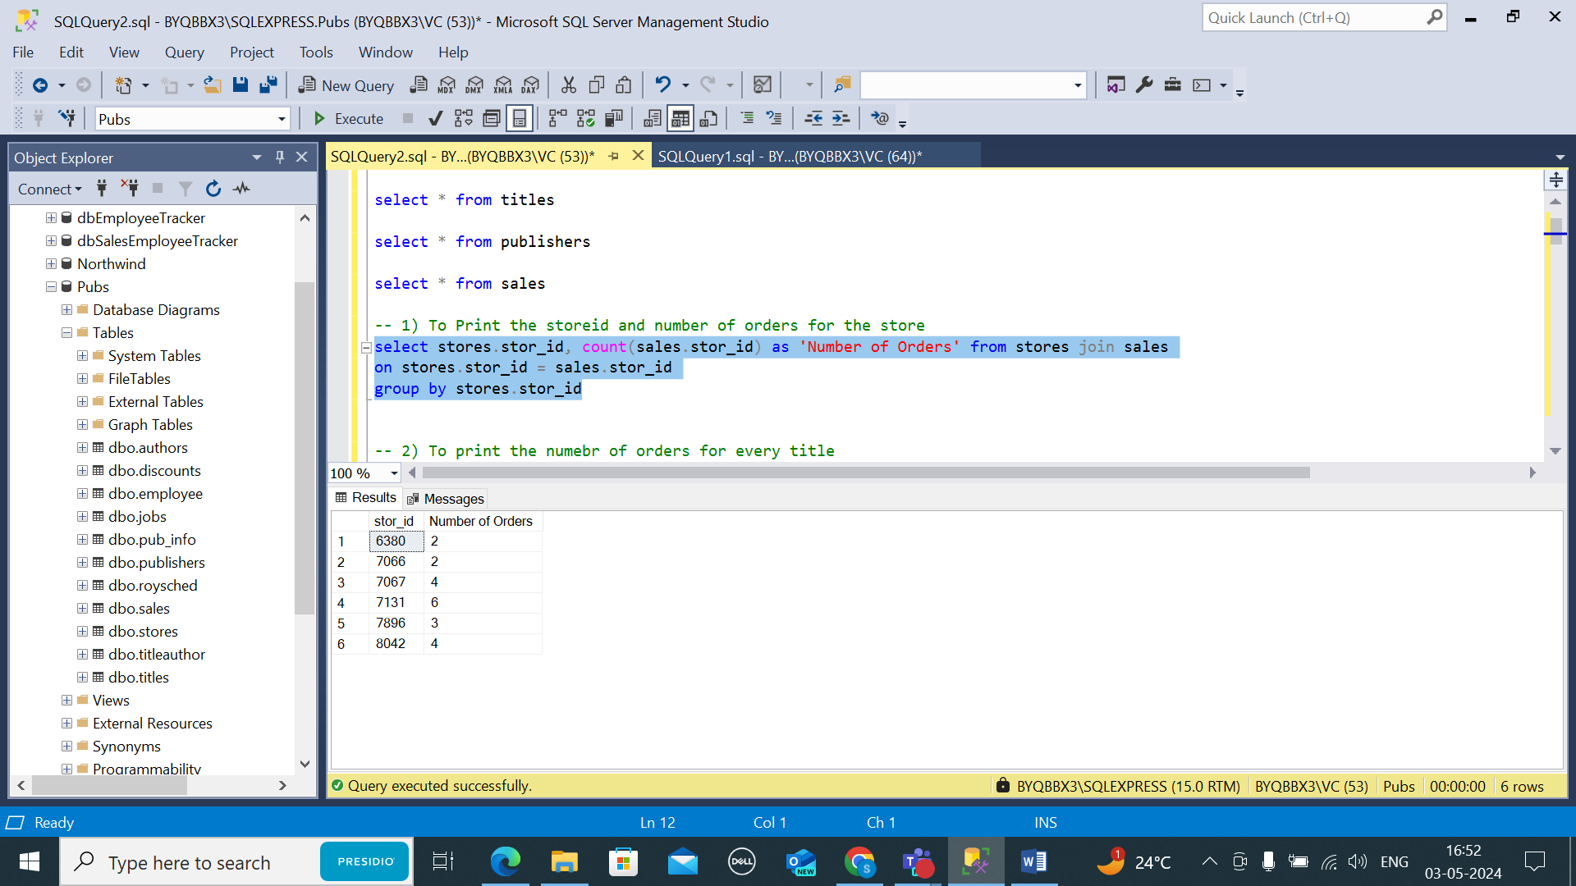

1. To print the number of orders for every title

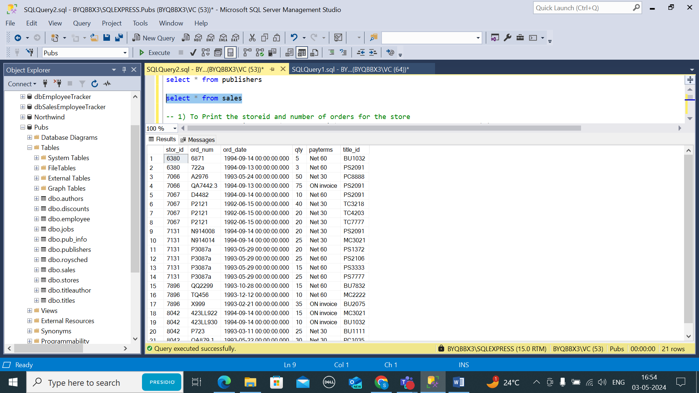

1. To Print the publisher name and book name

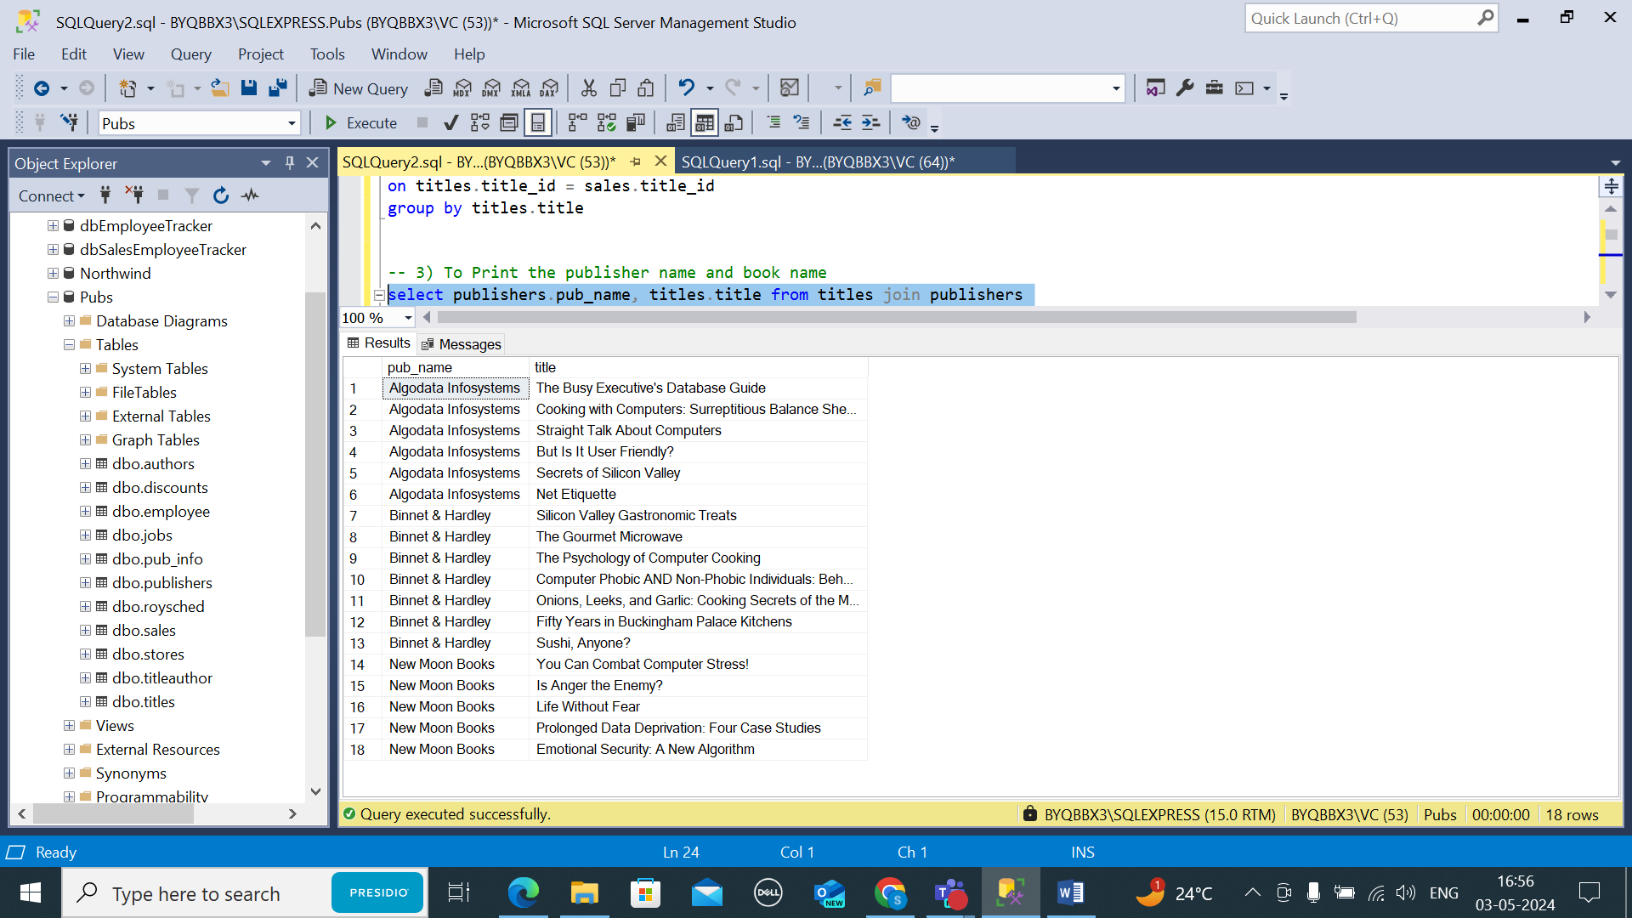

1. To Print the author full name for all the authors

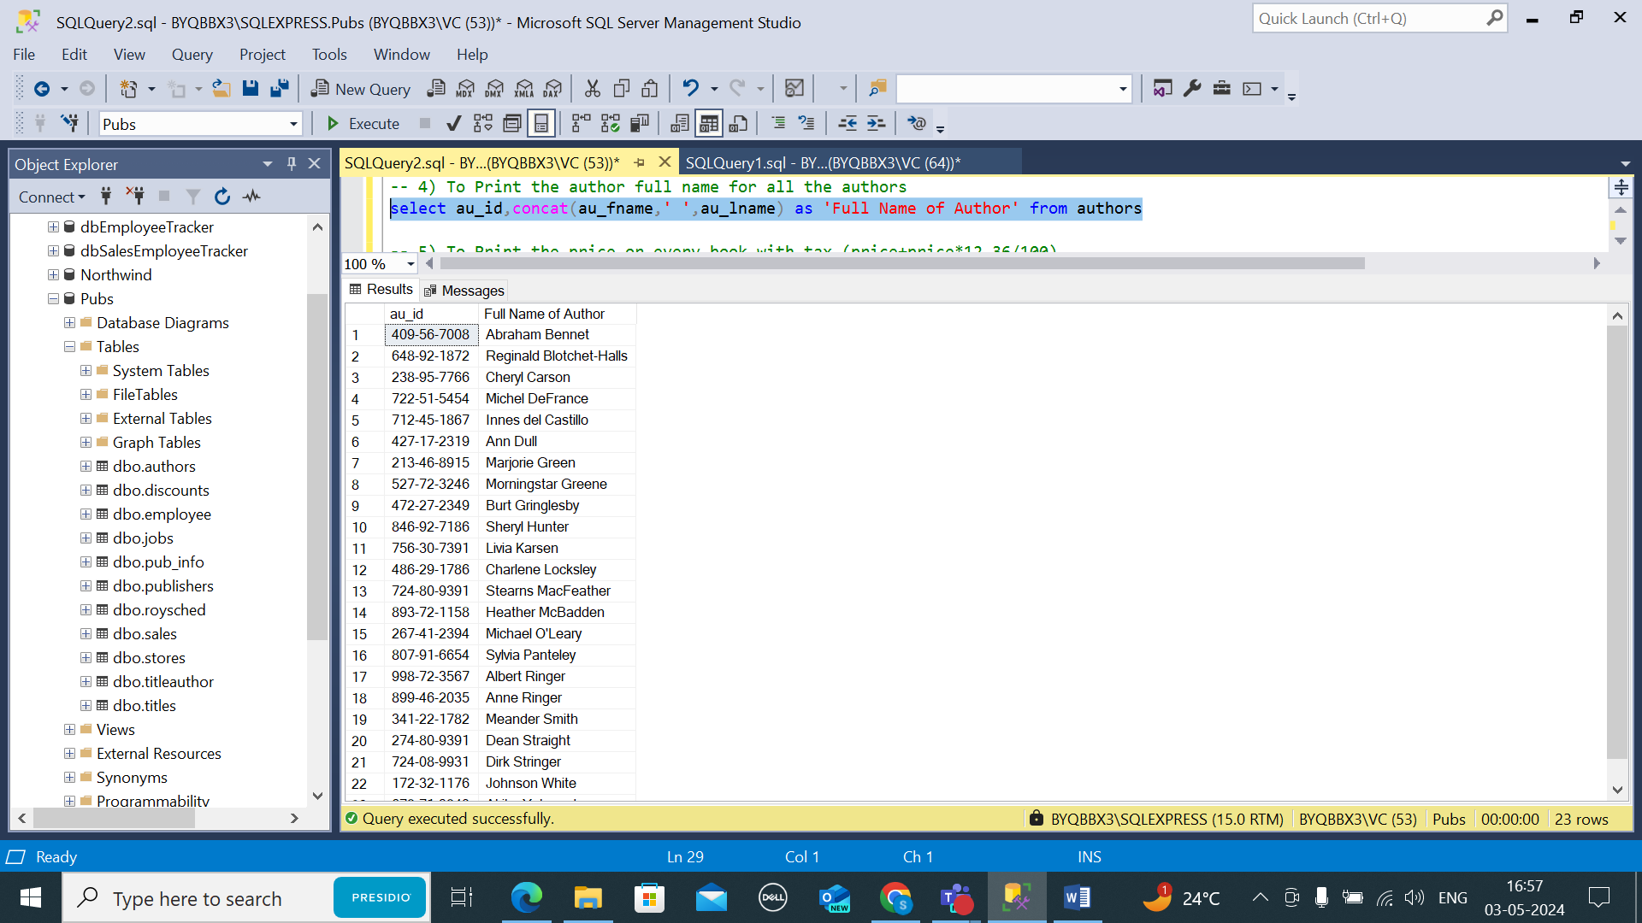

1. To Print the price or every book with tax (price+price\*12.36/100)

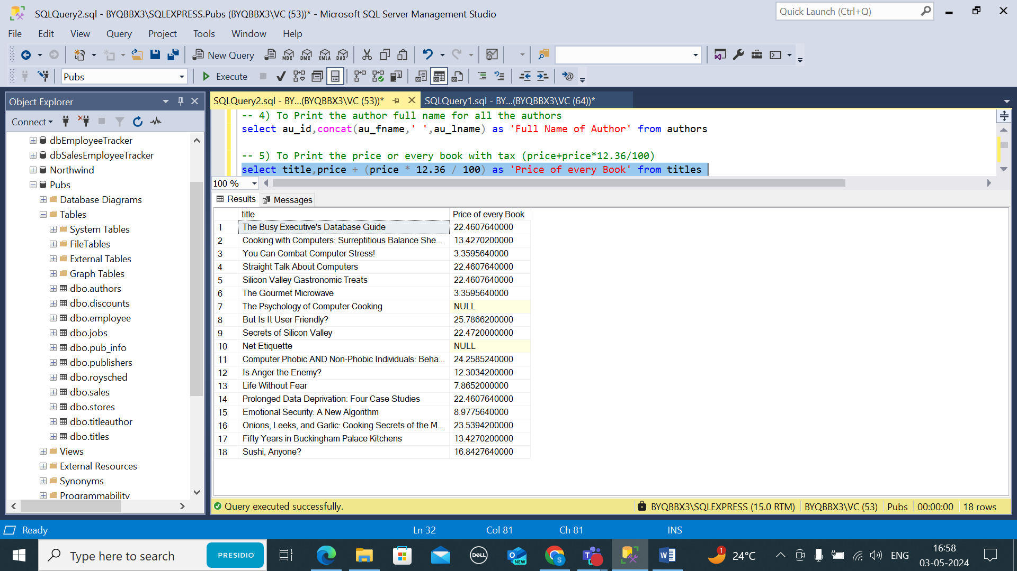

1. To Print the author name, title name

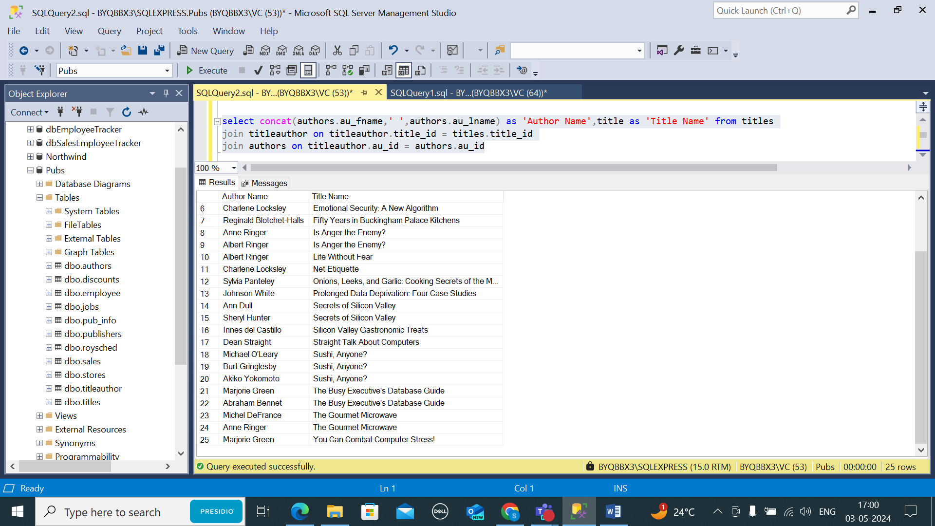

1. To print the author name, title name and the publisher name

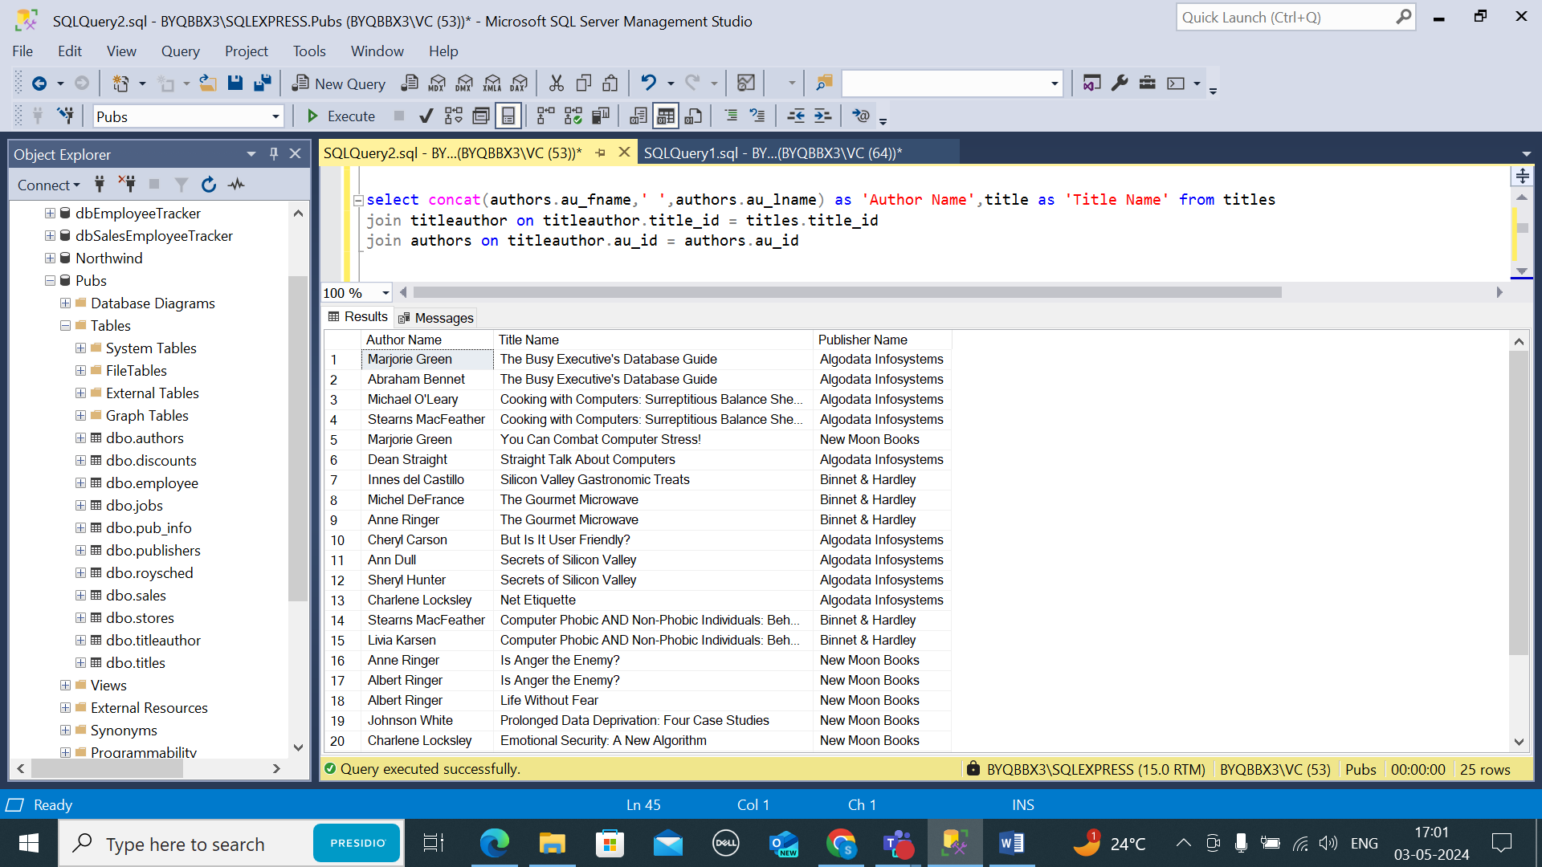

1. To Print the average price of books pulished by every publicher

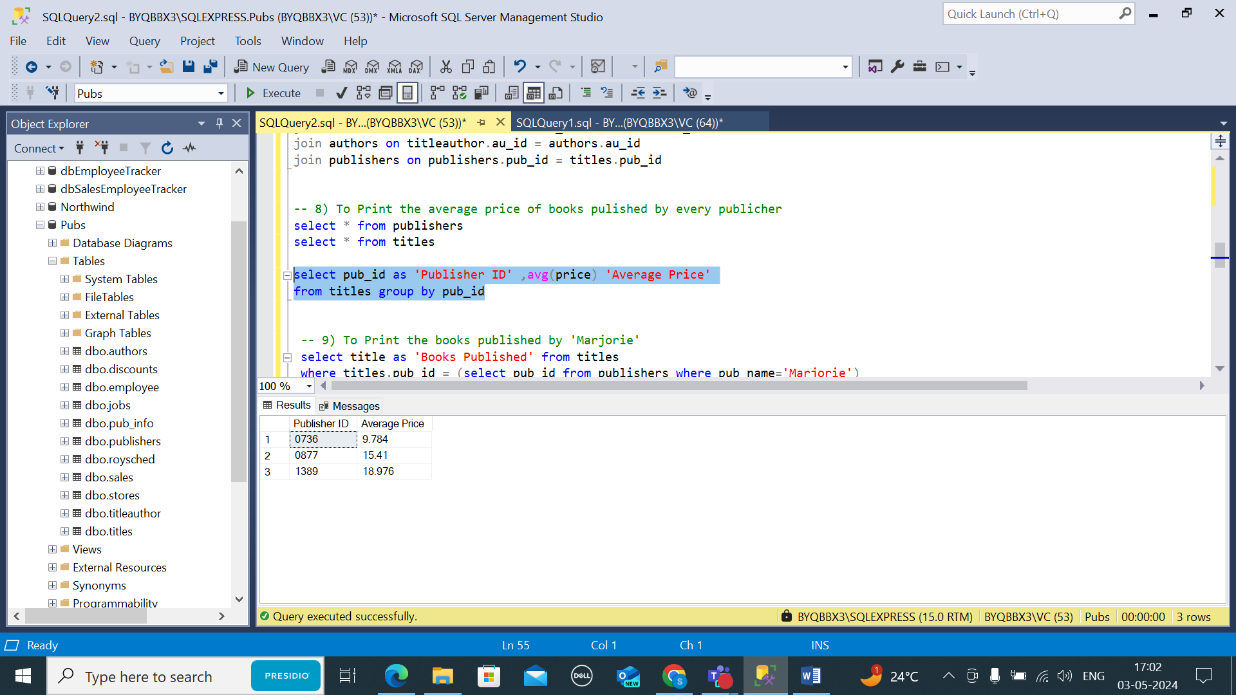

1. To Print the books published by 'Marjorie'

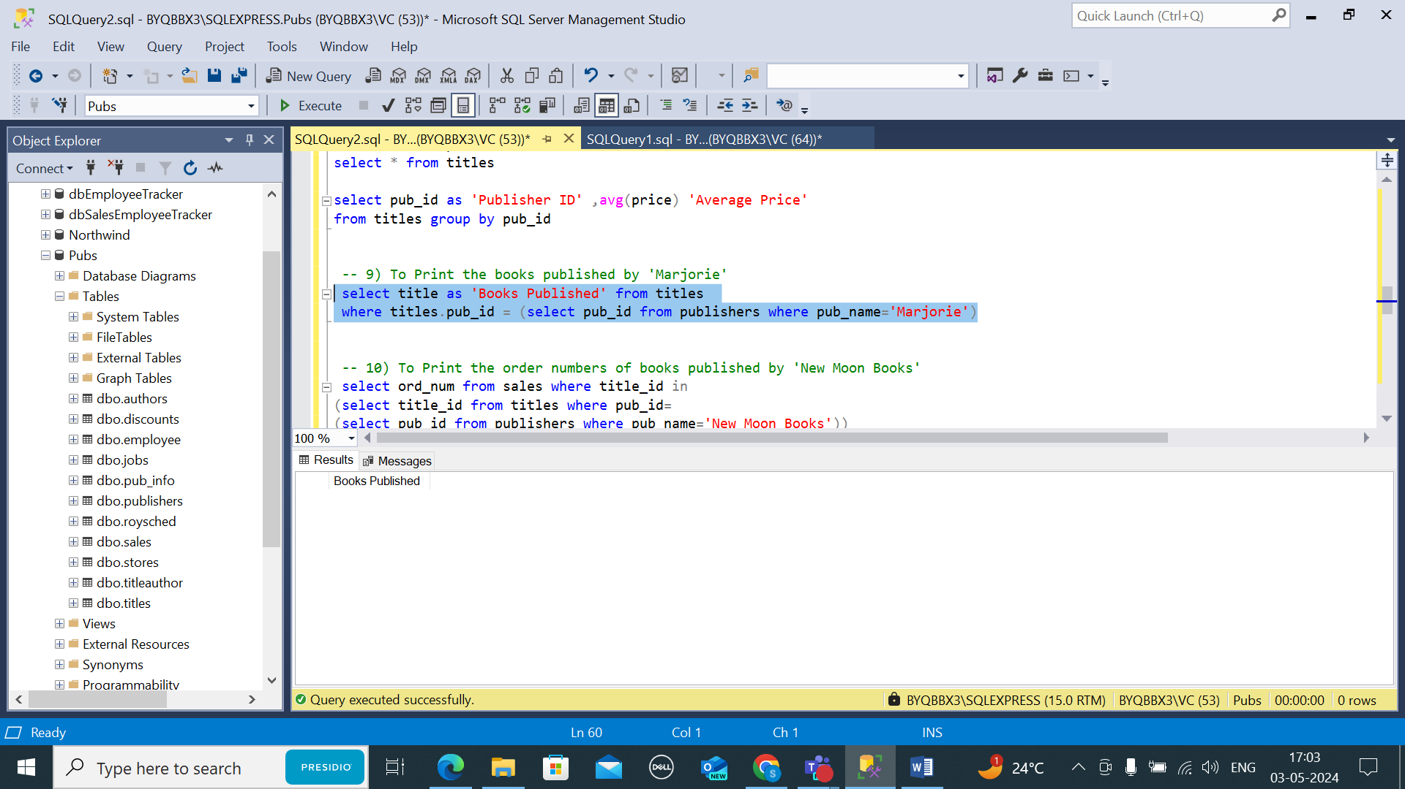

1. To Print the order numbers of books published by 'New Moon Books'

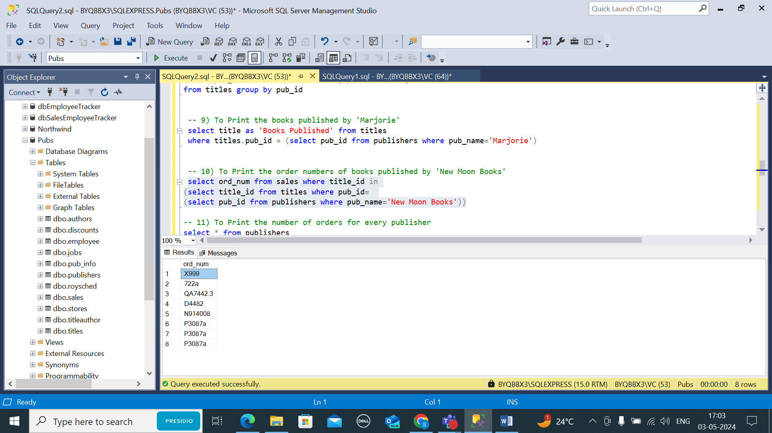

1. To Print the number of orders for every publisher

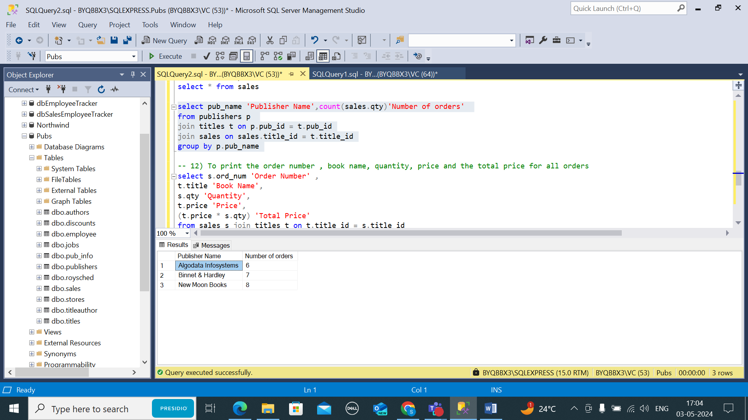

1. To print the order number , book name, quantity, price and the total price for all orders

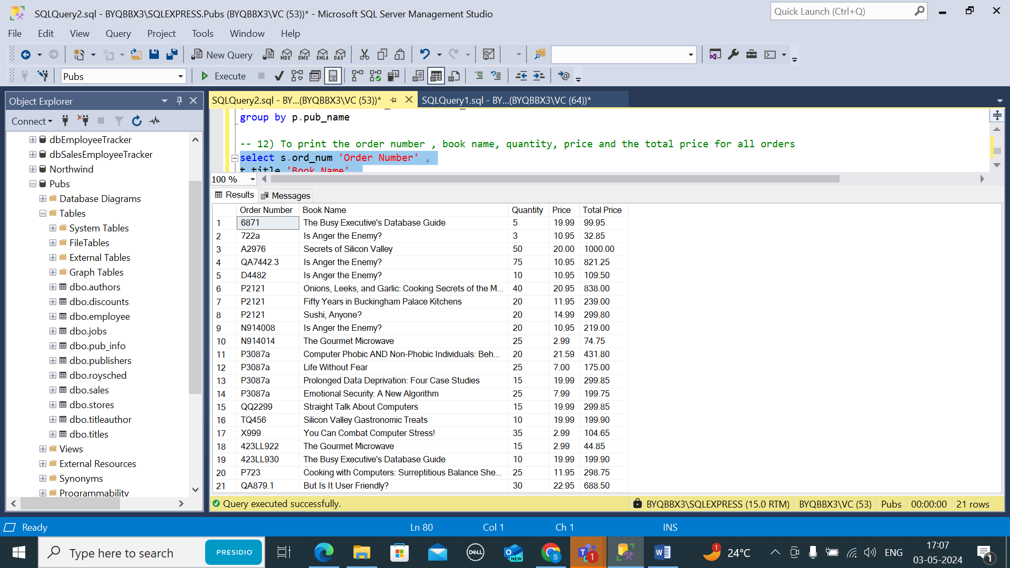

1. To print he total order quantity fro every book

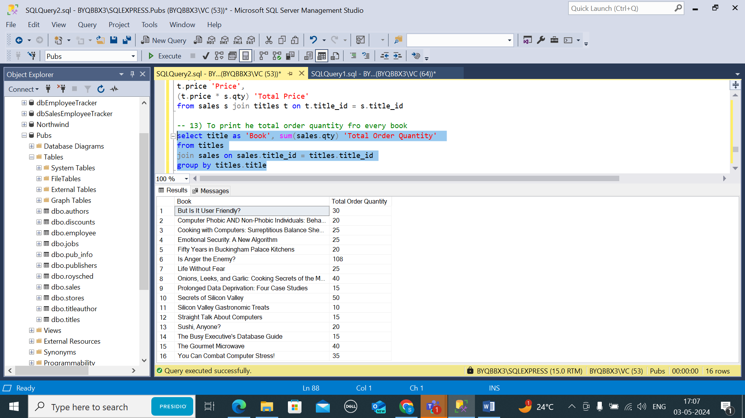

1. To print the total ordervalue for every book

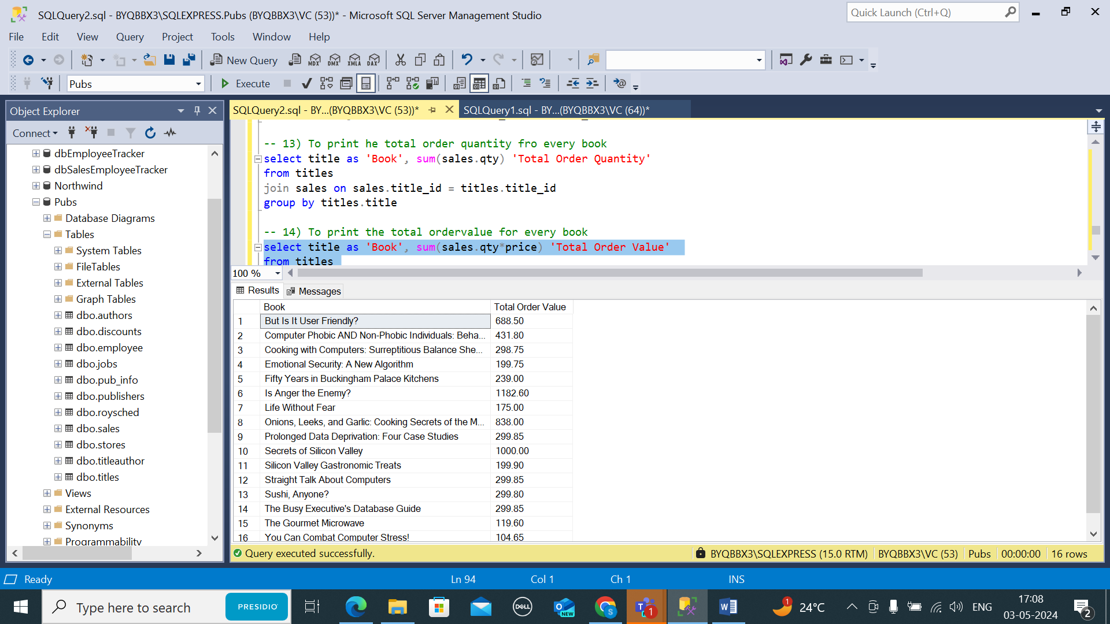

1. To print the orders that are for the books published by the publisher for which 'Paolo' works for

